Arduino-Based Automatic Plant Watering System with Moisture Level Display

Title Page
Project Title: Arduino-Based Automatic Plant Watering System with Moisture Level Display
Student Name: [Your Name]
Institution: [Your Institution]
Department: [Your Department]
Date: [Insert Date]

Abstract
This project presents an Arduino-based automatic plant watering system designed to optimize irrigation using real-time soil moisture monitoring. A soil moisture sensor continuously measures the water content in the soil and sends data to the Arduino microcontroller. Based on predefined threshold values, the system automatically controls a water pump through a relay module to irrigate the plant when required. Additionally, a 7-segment display driven by a BCD-to-7-segment decoder IC provides real-time visualization of soil moisture levels. The system reduces water wastage, minimizes manual intervention, and demonstrates a low-cost embedded solution for smart irrigation.

Introduction
Water scarcity and inefficient irrigation practices are major concerns in both domestic gardening and agriculture. Manual watering often leads to overwatering or underwatering, which can negatively affect plant growth. Automation using embedded systems provides an efficient solution to this problem.
This project uses an Arduino microcontroller to automate the irrigation process based on soil moisture levels. It integrates sensors, actuators, and display systems to create a compact and intelligent watering system suitable for home and small-scale agricultural use.

Objectives
- To design an automatic plant watering system using Arduino
- To monitor soil moisture levels in real time
- To control a water pump based on soil condition
- To display moisture levels using a 7-segment display
- To reduce water wastage through automated irrigation

System Overview
The system consists of a soil moisture sensor, Arduino UNO, relay module, water pump, and a 7-segment display system. The sensor detects moisture levels and sends analog signals to the Arduino. The Arduino processes this data and decides whether to activate the water pump. The moisture level is also displayed using a 7-segment display driven by a BCD-to-7-segment decoder IC, providing a simple numeric output for users.

Components Used
- Arduino UNO – Microcontroller for processing sensor data
- Soil Moisture Sensor – Measures moisture content in soil
- Relay Module – Acts as a switch for the water pump
- Water Pump – Provides irrigation
- 7-Segment Display – Displays moisture level
- BCD to 7-Segment Decoder IC (7447 / 4511) – Converts BCD input to display output
- Power Supply – Powers the system
- Jumper Wires – Electrical connections

Working Principle
- The soil moisture sensor continuously measures the moisture level in the soil.
- The sensor outputs an analog signal proportional to moisture content.
- The Arduino reads this signal and converts it into a usable moisture value.
- If the moisture level falls below a predefined threshold, the Arduino activates the relay module.
- The relay switches ON the water pump, supplying water to the plant.
- Once the moisture level reaches an acceptable range, the Arduino turns OFF the pump.
- The current moisture level is simultaneously sent in BCD format to the decoder IC, which drives the 7-segment display.

BCD to 7-Segment Display System
A BCD (Binary Coded Decimal) to 7-segment decoder IC is used to simplify the display circuit. Instead of controlling all segments individually using multiple Arduino pins, the BCD decoder converts a 4-bit binary input into signals that directly drive the 7-segment display.
This approach reduces the number of required microcontroller pins and simplifies wiring complexity. Common ICs used include the 7447 and 4511 decoder drivers.

Circuit Diagram
[Insert Circuit Diagram Here]
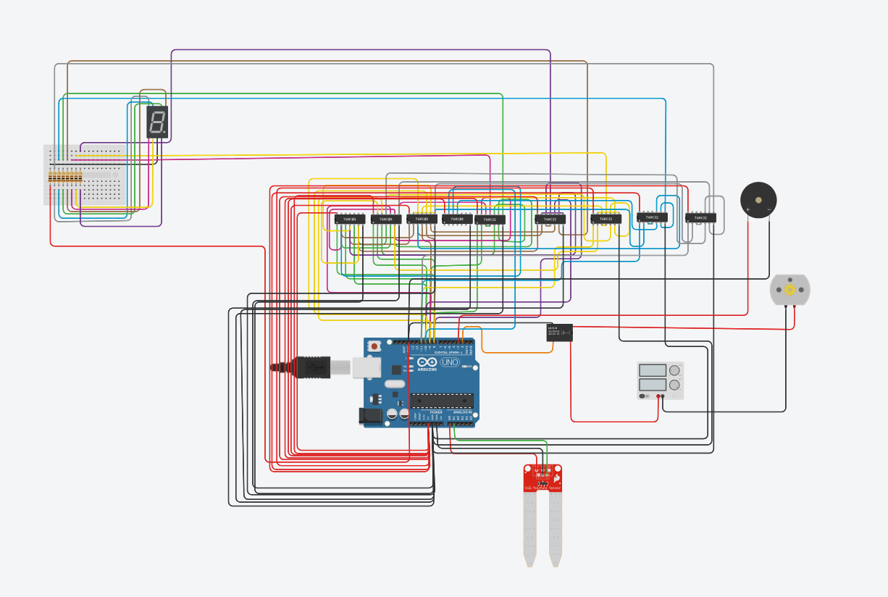.

- Soil Moisture Sensor
- Arduino UNO
- Relay Module
- Water Pump
- BCD-to-7-segment decoder IC
- 7-segment display connections

Flowchart
- Start
- Read soil moisture sensor
- Process moisture value in Arduino
- Display value on 7-segment display
- Compare value with threshold
- If dry → turn ON pump
- If wet → turn OFF pump
- Repeat loop

Advantages
- Fully automated irrigation system
- Saves water and energy
- Real-time moisture monitoring
- Simple and low-cost design
- Reduced manual effort

Limitations
- Accuracy depends on soil sensor calibration
- Limited to small-scale applications
- Requires stable power supply
- Sensor may degrade over time in soil

Future Improvements
- Integration with IoT for remote monitoring
- Mobile app-based control system
- Multi-plant zone irrigation system
- Use of weather prediction for smarter watering decisions
- Replacement with capacitive soil sensors for better durability

Conclusion
This project successfully demonstrates an efficient and low-cost automatic plant watering system using Arduino. By integrating soil moisture sensing, relay-based control, and a BCD-driven 7-segment display, the system provides both automation and real-time feedback. It reduces water wastage and eliminates the need for manual watering, making it suitable for home gardening and small agricultural applications.

